Add Other Charges to an Existing Repair Order in ROM: This topic covers how to use ROM to add other charges to an existing RO.

Access an Existing Repair Order: If the screen is blank to start with, either type the RO number in the Repair Order field or use the Search to look it up. If you already have an RO open, you will need to click New Repair Order to clear the screen and open the RO you want to add the charges to.

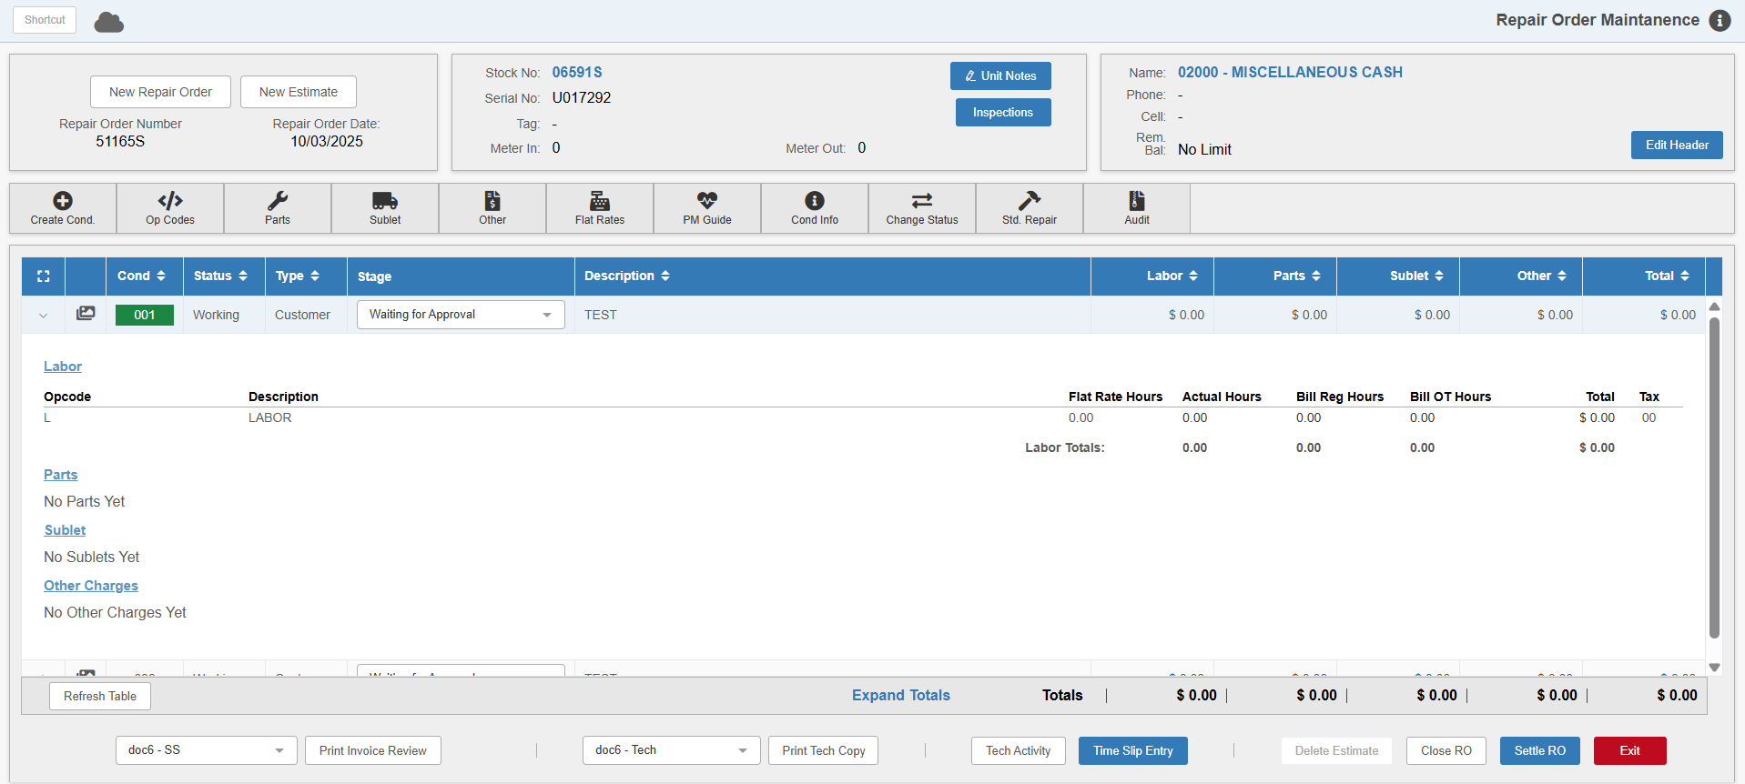

Adding the Charges: Click on the desired condition to expand the window, then click Other Charges to open the following window:

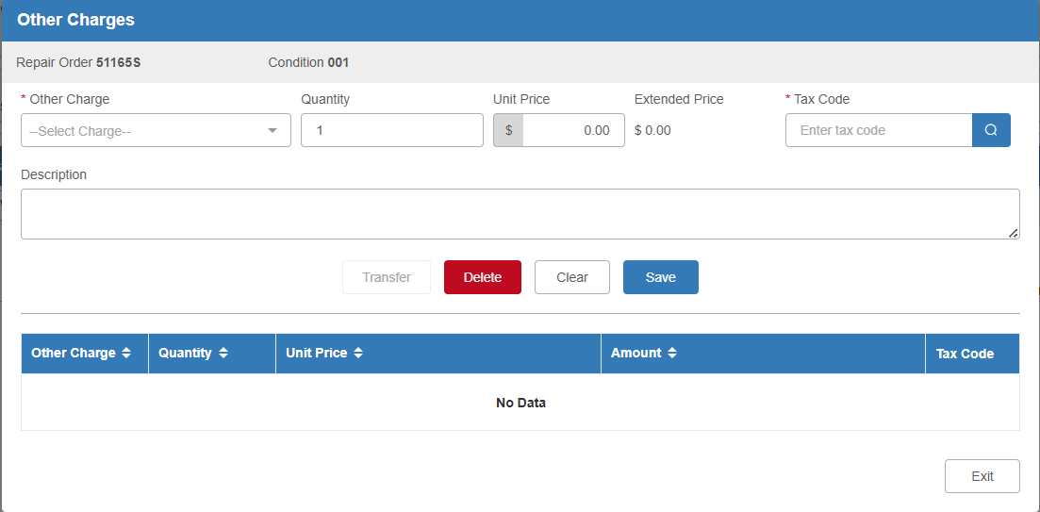

Other Charge: Enter the Other Charge code or select it from the drop-down menu.

Quantity: Enter the quantity of the charge or leave it as “1” if you only need to add one charge.

Unit Price: Fill in the unit price to calculate the Extended Price (Unit Price x Quantity = Extended Price).

Tax Code: The tax code is read from the Customer Master, but can be changed as necessary. If the customer does not have a default tax code set, you will need to enter one in order to add the charge.

Description: This field is optional, but can be used to hold information about the charge.

Save: Click this button to save the charge.

You can add as many charges as you want in this screen. They will show in the grid in the bottom half as they are added.

Exit: Click this button when you are done adding charges. You will be returned to the main screen, and any charges you added will appear in the Other Charges section of the condition’s details.

